Document for Operation (DFX)

DYNATRACE v2.0

|  |  |
| --- | --- |
| Reference |  |
| Pages | 22 of the Annexure (s) : |
| Index | 2.0 |

|  |  |  |  |  |
| --- | --- | --- | --- | --- |
| Accessibility | ☐ Access Reserved | ☒ Restricted | ☐ Internal (CSPI) | ☐ Free (GDF Suez) |

|  |  |
| --- | --- |
| Summary | |
| ***This document contains the Technical Operational Procedure of the DYNATRACE v2.0 Application*** | |
| Key(s) Word(s) |  |

|  |  |
| --- | --- |
| Classification |  |

|  |  |  |  |  |  |
| --- | --- | --- | --- | --- | --- |
| VALIDATION OF THE DOCUMENT | | | | | |
| Editor(s) | | Verifier(s) | | Approver(s) | |
| Name/Entity | Date/Visa | Name/Entité | Date/Visa | Name/Entité | Date/Visa |
| name first name |  | Name pré nom, fonction |  | Integrator of the Operation |  |

|  |  |
| --- | --- |
| DIFFUSION | |
| List of Persons | Entities |
|  |  |

|  |  |  |  |
| --- | --- | --- | --- |
| HISTORY | | | |
| Index | Date | Author(s) | Statement(s) |
| 1.0 | 06/08/2013 | 1. Lim + S. Emiel | Creation of the document on the basis of the PTE supplied by Compuware |
| 2.0 | 21/10/2013 | P. Meurisse + Y. Métivier + S. Emiel | Upgrade following the cross-checking by ATOS |
|  |  |  |  |
|  |  |  |  |
|  |  |  |  |

**Brief Summary**

1. **General description of the application**
   1. ***Application Purpose***

* + 1. ***Actualization of the implementation project, of Compuware DCRUM and Dynatrace for GrDF***

The Information System department of GrDF wishes to set up a solution for the monitoring and reporting on the critical applications so as to identify the sources of their degradation and improve their performance.

A joint operational programme was done with the Vantage Solution (V11.6) and Dynatrace of Compuware on four applications taken as reference points (on those most critical)

- O2 with 2 points of reference

- Caribbean area with 2 reference points

- SIG-GAZ with 1 or 2 test point

- CII-GAZ with 1 test point

GRDF wishes to put into production this solution by covering the same scope of the application as the JOC then to enlarge it by progressively integrating a number of more important applications (≈50 applications).

The deployment in the production of the Compuware Solution will be done with the V12 DCRUM version by reusing the AMD of the JOC while waiting for the delivery of the AMD targets

* + 1. ***Implications for GDFSUEZ-IT***

The challenge for GDFSUEZ-IT is to delivery internally a solution for the surveillance of application performance.

This offer allows the clients to satisfy the following needs:

* Measure the user experience through the availability/ performance of the applications.
* Arrange for a local or topical observation (user/ sites affected) to recognise the impact of a degradation and accelerate the rate of diagnostic in case of incidents.
* When the case permits, have internals application indicators available to more accurately identify the source of the degradation.

The proposed solution is not a solution of audit application or of troubleshooting of the incident. It aims to detect the degradations of the application performances and to provide the indicators for encrypted communication of the entities concerned.

The solution retained is DCRUM, which offers the vision of service centred on the user experience and delivered by the assembly of the resources of IT.

This solution should allow GrDF to supply a management of the end to end of the performance of the applications and to respond **to their profiles** (study case to case) to the following problems:

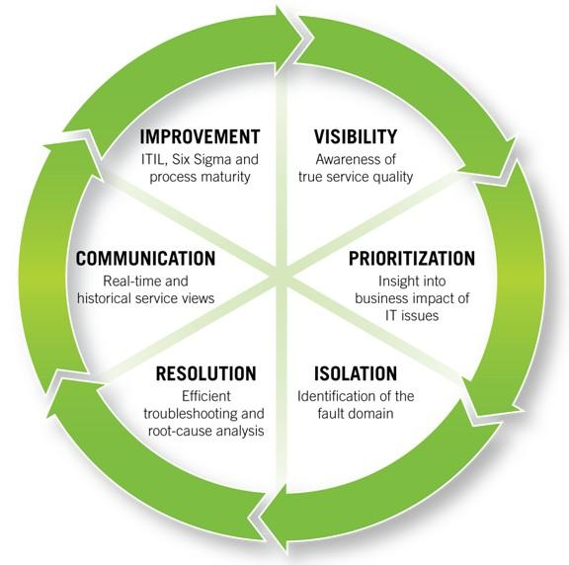

* **Visibility of the level of service offered to the user.** Offer of the visibility of the quality of the service based not only on the vision of the components or the technology but based on a final vision of the user.
* **Prioritization of the incidents:** Understanding the business impact to prioritize the actions with efficiency.
* **Isolation of the incidents**: Rapidly identify the domain of application at fault.
* **Resolution**: Benefit from tools adapted to localize the problem and solve it.
* **Communication**: Communicate effectively by giving the right information to the right persons i.e. to the operational team, those responsible for IT and business managers.
* **Improvement**: Implement the processes which is appropiate for analyzing the results and identifying the areas of improvement.

* 1. ***General operation***

The Dynatrace platform includes a Dynatrace server, a collector and a Dynatrace Analysis Server installed on an ISV and the Dynatrace agents installed on the third parties application O2.

The database of the Dynatrace server is installed locally on the ISV.

* 1. ***Main Personnel*** 
     1. ***List of the « contributors of the operation »***

|  |  |  |  |  |
| --- | --- | --- | --- | --- |
| **People** | **Entity** | **Function** | **Telephone** | **BAL** |
| Manager of the O² application  Perrine The bas | GrDF | DSI – Domain of Network Performance | 06 83 24 64 28  01 71 18 58 15 |  |
| NetRun | TSM | Operation of the network |  | Dsi-One-It-Tsm-NetRun-Datacenters-Security |
| SRM GrDF | ASM | Technique of Operation |  | [dsi-one-it-asm-srm-grdf@gdfsuez.com](mailto:dsi-one-it-asm-srm-grdf@gdfsuez.com)  dsi-one-it-asm-middthe ware_windows@gdfsuez.com |
| ESM | Expert Opinion |  | +33 (1) 49.18.84.66  +32 (2) 206.33.26 | its.monitoringdesign@electrabel.com  [dsi-cspi-supervision@gdfsuez.com](mailto:dsi-cspi-supervision@gdfsuez.com) |
| SU&W | ISM | Outsourcer Management | +33 (1) 49.18.85.00 | it-infra-ism-suw@gdfsuez-it.com |
| Atos | Atos LOT6 | OS Operator |  | it-infra-lot6@gdfsuez-it.com |

*Remark: Always Indicate « DYNATRACE » at the start of the mails..*

* + 1. ***Who can validate the stop-start of the application***

*In case of the occurrence of an incident, only the POA or the person responsible for the MCO can validate a stop-start, either partial or global of the application.*

***POA - O² GrDF Perrine Lebas***

* + 1. ***List of people authorized to implement the requirements of the application***

Only the following people are authorized to carry out the work required for the application :

GrDF: Perrine The bas GrDF

ESM : g_dsi_cspi_supervision_sn3

ASM: EXP_DSI-ONE-IT-ASM-GRDF_SN2

ISM: G_DSIG_PEXSI_SN2

* 1. ***Distribution of the activities of the operation for the application***

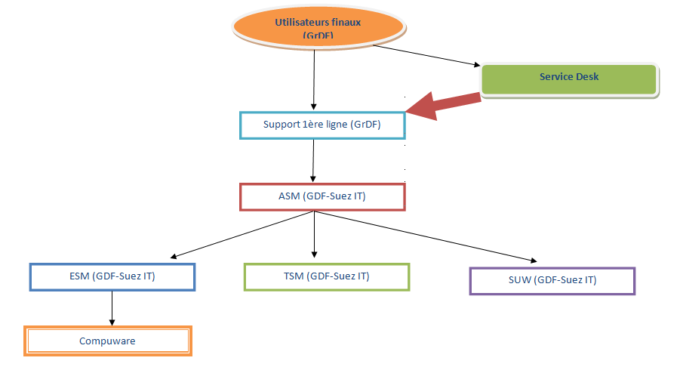

Utilisateurs finaux : Final Users

Service Desk

Support 1ere ligne (GrDF): Frontline support (GrDF)

ASM (GDF- Suez IT)

ESM (GDF- Suez IT)

TSM (GDF- Suez IT)

SUW (GDF- Suez IT)

Compuware

* + 1. ***Operation of the system***

|  |  |  |  |
| --- | --- | --- | --- |
| **Machine** | **Technical  System** | **OS** | **Incharge of the operation** |
| h1w1dcr00c.dc.infra.com | PRD: SRV_DYNATRACE | Windows 2008 R2 | Atos LOT6 |

SUW (ATOS) will be responsible for the operation of the IS*.*

*In case of an event occurring on DYNATRACE, the patrol supervison agent generate a Simulated Event note at ARIs which processes this event and if the need arises escalates it to GDF SUEZ IT - SUW.*

*SUW transfers this event then to GDF SUEZ IT– ESM -BAL Dsi-Cspi-Supervision and informs the GrDF referee in ASM so that it may alert GrDF of the event. The ASM redirects it towards appropriate technical support cells. Then ESM can address the needs of Compuware for the analysis and resolution of the event (sends email to request the opening of the Support ticket of Compuware.)*

* + 1. ***SGBD Administration***

|  |  |  |  |
| --- | --- | --- | --- |
| ***Server*** | ***Base Name*** | ***Base Type*** | ***Administrator*** |
| *H1W1DCR00C* | *DYNATRACE5* | *SQL Server standard 2008* | *PST / MIDDTHE WARE WINDOWS* |

* + 1. ***Technical and application lead***

Surveillance, retrieval and installation of the middleware Compuware components.

GDF SUEZ IT does not monitor the technical applications with the Compuware tools; this is the responsibility of the technical department

Outside this perimeter: All problems of the application linked to the use of the Compuware tools and all problems detected by the Compuware tools on the GrDF applications.

DYNATRACE /

* ASM for surveillance and taking into account the requirements/ events, then the redirection towards the appropriate technical support cells (Intervention of COMPUWARE via ESM).

* ATOS via SU&W for the operation of the srvers and the backups.
* Compuware/ESM for the analysis of the events, the audits of the application and the procedure modifications.

* + 1. ***Functional direction***

**The monitoring of the application lines with the Compuware tools is the responsibility of the GrDF department**

* 1. ***Identification of the application***
     1. ***Trigram of the application***

IO KIR = DYN

* + 1. ***Application Environments***

|  |  |  |  |
| --- | --- | --- | --- |
| **Environment** | **Server(s)** | **The level of service** | **Engagement (Standard or higher)** |
| Production | h1w1dcr00c.dc.infra.com | N5/N5 | Not Standard  Absence of Pre-Production |

* + 1. ***History of the application versions***

|  |  |  |  |
| --- | --- | --- | --- |
| **Version** | **Production date** | **Sites** | **Content** |
| 5.5 |  | S2 | Dynatrace |

* 1. ***Security, constraints, and the level of service***
     1. ***General level of service***

Environment : PRODUCTION

|  |  |
| --- | --- |
| **Parameter** | **The vel of service** |
| Classification of the application | No Specific Classification |
| Open section for the users | 8H-18H 5/7 |
| Availability level of EAC | 7H-19H 5/7 (N5 / N5) |
| Administration level of the EAC | 7H-19H 5/7 (N5 / N5) |
| DMZ intranet for the Reporting Servers | To be filled by TSM |
| PSI | None |

* + 1. ***Communication with other applications***

Not relevant

* + 1. ***Data and interfaces exchange***

Not relevant

* + 1. ***Exchange Flow chart***

Not relevant

* 1. ***General Architecture*** 
     1. ***General Synopsis***
        1. Functional Architecture of DYNATRACE

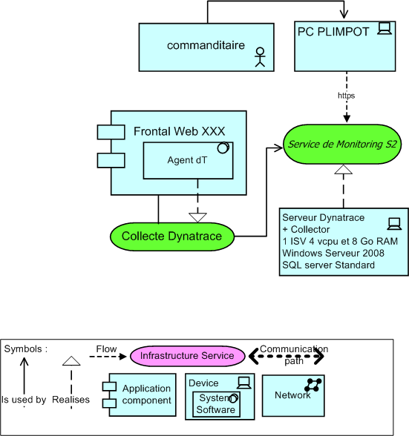

Commanditaire : Originator

PC PLIMPOT : PC PLIMPOT

Frontal Web XXX  Frontal Web XXX :

Agent dt : Dt Agent

Server of Monitoring S2 S2 Monitoring Server

Collecte dynatrace Dynatrace Collection

Server Dynatrace +Collecteur Dynatrace Server + Collecter

*Windows Server 2008 Windows Server 2008  
SQL server Standard SQL server Standard  
Application Component Application Component*

* + 1. ***Physical architecture***

|  |  |
| --- | --- |
| **Type** | **Number** |
| **ISV** | 1 |

* + 1. ***Detailed description of the Servers***
       1. Configuration of the Physical Server :

***N/A***

* + - 1. PROD Environment

PROD Environment – Server h1w1dcr00C

|  |  |
| --- | --- |
| **Component** | **Detail** |
| Inventory Name | h1w1dcr00c |
| Mark and model | ISV VMware |
| RAM | 8 Go |
| CPU (Number and Frequency) | 4 vCPU |
| Localisation | S2 |
| @IP | 10.249.4.196/26 (GW : 10.249.4.193) |
| Network Interfaces (type, speed, mac) | *Front End Card* 10.249.4.196 (Priority Used)  Back end card10.249.36.196  *Admin Card* 10.249.68.196  Card10.249.132.196 |
| Internal Disks (Number, capacity, RAID type) |  |
| FC Cards |  |
| SAN Stockage | 200 Go |
| Version OS | Windows 2008 R2 |
| Software Products (Name et version) | Compuware Software package DYNATRACE |

* 1. ***Products necessary for the application***

**Warning, if a product, which is described, does not figure in the technical support reference by DSI, it is important to indicate the replacement support defined by POP/POA.**

* + 1. ***Products of communication***
       1. Communication batch

Not relevant

* + - 1. Transactional Communication  
          Not relevant
    1. ***Products of surveillance***

BMC Patrol

* + 1. ***Data Backup products***

NETWORKER

* + 1. ***Production Control Products***

Not relevant

* + 1. ***Data Support Product***

MS SQL 2008 R2

* + 1. ***Other products***

Not relevant

* 1. ***Volumetry of the database files*** 
     1. ***List of the database and the foreseen development of the volumetry.***

|  |  |  |  |  |  |
| --- | --- | --- | --- | --- | --- |
| **Base** | **Server** | **Volumetric Reference** | **Date of the Volumetric Reference** | **% Growth forecast** | **Basic Function** |
| DYNATRACE5 | h1w1dcr00C | 200 Go | 07/2013 | 0% per year (quota to be fixed) | Warehousing of the data sent by the DynaTrace Collector |

* + 1. ***Detail of the database files***

**DYNATRACE EVENT**

|  |  |  |  |
| --- | --- | --- | --- |
| **Implementation Index** | **File** | **Size** | **Role** |
| E:\Program Files\Microsoft SQL Server\MSSQL10_50.MSSQLSERVER\MSSQL\Data\ | dynatrace5.mdf | 1,27 Go | Data File |
| F:\Program Files\Microsoft SQL Server\MSSQL10_50.MSSQLSERVER\MSSQL\Data\ | dynatrace5_log | 3,31 Go | File s of transaction |

* 1. ***Establishment of the application on the Server H1W1DCR00C (Production) DYNATRACE***
     1. ***Configuration of the Internal disks***

**Type of stockage : DATA-STORE (ESX)**

|  |  |
| --- | --- |
| **Disk Unit** | **Description of the Content** |
| C (32Go) | System |
| D (15 Go) | Main software application |
| E (200 Go) | Stockage of the data of SQL Server |
| F (25 Go) | Stockage of SQL Server transaction log |
| G (15 Go) | Stockageof data and transaction report of the temporary table of the SQL Server |

* + 1. ***Establishment of software other than the main***

N/A

* + 1. ***Establishment of the application and of the data***

N/A

* + 1. ***General Flow chart of the applications physical locations***

N/A

* + 1. ***Application accounts***

WINDOWS :

**Administration shared between PST method of operation ( admin account pst) and LOT6 ( secadm account)**

|  |  |  |  |
| --- | --- | --- | --- |
| **Account** | **Group** | **Utility of the account** | **Account Incharge** |
|  |  |  |  |
| Local Service | Local | Account used for the Dynatrace Windows services | PST |
| sqlsvc | SQL | Database Service Account (connection between Dynatrace and the Server SQL) | PST |

Technical Accounts

|  |  |  |  |
| --- | --- | --- | --- |
| **Account** | **Group** | **Utility of the account** | **Account Incharge** |
| AdminPST | Administrator | Account reserved for the PST Administrator use | PST |
| AdminEXP | Administrator | Account reserved for the Tooling Expert | ESM Tooling Expertise |

1. * 1. ***List of application executables***

Not applicablee because Compuware is responsible for assistance at level 3 on the application in case of an event.

* + 1. ***List of configuration and application parameters files***

Not applicablee because Compuware is responsible for assistance at level 3 on the application in case of an event.

* + 1. ***List of System parameters***

N/A Root Not modified

* + 1. ***Detailed presentation of the Interface***

1. ***Some concepts***

Source (network): server, which initiates the IP connection.

Flow direction: « Mounting, » means that the « source » sends data to the « target», «descending, » means that the « source » recovers data from the « target».

* 1. ***APPLICATION TREATMENT***
     1. ***General Synopsis of the treatment***

Not applicable.

* + 1. ***Calendar treatments***

1. Standard SQL maintenance plan under the agesis of PST.

1. **Operating instructions of the present System**
   1. ***Surveillance of the Server H1W1DCR00C***

The definition of surveillance under the agesis of the Project is given in the document named « SDS » (Supervision Services).

These surveillances had been implemented here by the Supervision Expert and the resulting incidents are reported directly in the BEM: GDF / Applications / DYNATRACE, bypassing the BEM ATOS.

* + 1. ***Surveillance of the Systems Files***

Standard Surveillance.

In the case of the outstripping of the threshold of a disk unit other than C: (System), the event is rerouted to ASM, of Group SIMILI: **EXP_DSI-ONE-IT-ASM-GRDF_SN2.**

|  |  |  |  |
| --- | --- | --- | --- |
| **Filesystem** | **Threshold warning** | **Critical Threshold** | **Assigned** |
| Disk E | 80 | 90 | Contact Tooling Expert |

* + 1. ***Surveillance of the process***

**Surveillances managed by the Cortex ASM cell**

Cf. SDS DYNATRACE - Windows – Services + Warning Files

* + 1. ***Oracle Surveillance  
        Surveillance managed by the Cortex ASM cell***

SQL Server Surveillance : Supervison allowing us to ensure the database is online.

* + 1. ***Application Surveillances***

**Surveillances managed by Compuware / Tooling Expert.**

* 1. ***Backup***

* + 1. *General Information*

Backup of the200 Go on the Dynatrace ISV according to the standard Policy of backup of VMware:

1 Complete Backup per week with retention of 4 weeks of data on Saturday at 23 h

+ 1 Manual Backup with retention of 2 months of data

Backup is done by a VMware snapshot, mounted on a proxy of the type VCB/VADP. Then OBS with networker tool starts the full offline backup.

* + 1. *Policy of backing up of the H1W1DCR00C Server:*

Offers 1 THE N D.S.I catalogue list.

* + - 1. System Backup

Backup done by the Windows Backup Server (SSR2011).

* + - 1. Backup of data (NETWORKER)

Total Backup of VM (VCB).

* + 1. ***Reporting of the errors of Backup***

After analysis, the backup incidents encountered by the operator will be sent by mail to the contributors of the operation.

* 1. ***Purge of Files***

Not applicable: Automatic Recycling

* 1. ***Special Interventions on the System***

***N/A***

* 1. ***Processing : events, retrieval, restorations***

Remark : This chapter will be supplied progressively as and when the incidents occur during the operation.

**Incident or event**

|  |  |  |  |  |  |
| --- | --- | --- | --- | --- | --- |
| **Indicate the Name of the event** | | | **Creation :** date of creation of the file | | **MAJ :** date of updating the file |
| **Importance of the event :** *indicate whether this is blocking or not blocking* | **Time of resolution of the incident :** *Indicate here if the operator can immediately resolve the event or not (values : immediate, awaiting, and other).* | | | | |
| **Symptoms**  *Indicate the symptoms, which allow us to recognise or detect the event. Make a detailed description if possible* | | | | | |
| **Prescriptions / Retrievals :** | | | | | |
| **Action(s) :** | **Type :** | **Personnel(s) :** | | **Speaker (s) :** | |
| *Outline each action permitting the correction of an event. An action can be for example the checking of a file, the searching of the messages, insertion of a tape for backup purpose, opening of a data...* | **(1)** | **(2)** | | **(3)** | |

1. Indicate how to do the corrective action (value : batch, other).
2. Indicate who should carry out the corrective action (values : cti, usi, cnpe, Project team, Integrator, exs …).
3. Indicate whether the interlocutor intervene in case of problems on the action.

1. **Operating Instructions of the application**
   1. ***Test of the Operation of the application***

Undertaken by GrDF

* 1. ***Stop procedure of the application***

***N/A***

* 1. ***Procedure of the restart of the application***

**Production:**

**Servers Windows:**

No start-stop of the application or BDD is required by Compuware during normal operations.

In case of an event, it is necessary to open a Compuware Support ticket by utilising the event file supplied.

For the reboot of the Servers, one must follow the process of stop-restarting of Windows, which will stop the services in the order of dependencies. Use the restart function of Windows.

|  |  |  |  |  |
| --- | --- | --- | --- | --- |
| **Periodic Reboot of the Servers** | | | | |
| **Server :**  H1W1DCR02T  SRV_ADS_BDD  H1W1DCR04N SRV_CAS_WEB_BDD  H1W1DCR06H SRV_CAS_NET_BDD | **Place for the implementation of the batch file :**  To be defined | | **Name of the script :**  Reboot task planned | |
| **Processing Function :**  The processing includes a stop-start of the Windows services. | | | | |
| **Personnel (s) :** | | **Manual Action(s) :** | | **Actions automatic :** |
| ATOS | | None | | Launch mode:  Reboot task planned |
| **Periodicity :** to be defined | | **Conditions :** None | | **Hour : ⇨**  before midnight and after 7h Monday to Saturday |
| **Description of the treatment : Standard Reboot of the Windows Servers refer to ATOS** | | | | |
|  |  |  |  |  |

* 1. ***The application launchers***

***N/A***

* 1. ***Reception and flux emission checking***

None

* 1. ***Special interventions on the Application***

Supported by Compuware/Tooling Expert

* 1. ***Signaling and reassembling of the events***

Cf 1.4

The events unresolved by the operator or those not part of his responsibilities will be recovered by

tooling team expert for analysis and its processing with the help of the Compuware editor by reallocation of the incident file to the *g_dsi_cspi_supervision_sn3* group.

A mail or a telephone call will accompany the transmission of the event depending on its gravity.

The application having generated an application downtime or a major slowdown , as also backup problems will be reported by mail to the contributors of the operation.

1. **Log of the operation**

Not applicable

1. **SECURITY INSTRUCTIONS OF PSSI TO BE FOLLOWED**

In an approach to improve the security level of the SI, GDFSUEZ has communicated, by it Security Committee intermediary SI, a series of instructions:

Some of these measures are applicable to the installation dossier. Thèses are extracts of the following document.

Ref. DSI- Security-2005-010 – Security instructions : Checking of the software access of the Information System of GDGSUEZ

Ref. DSI-Security-2005-013 - Security instructions: Architecture and Operation- Information System Equipments

* 1. ***Inspection of the logical access of the Information System of GDFSUEZ***

|  |  |
| --- | --- |
| **Precautionary measure against fraudulent access** | |
| DIR-PCA-12 | The default access accounts (ex. manufactures accounts) to the applications, resources and operating system should be neutralised before the start of production (account suppressed or having a minimum lock by a complex password different to the default password). |
| DIR-PCA-13 | The accounts used during the development and the delivery / qualification phases should be suppressed during the commissioning. |
| DIR-PCA-49 | Directly readable copies of all credentials (example: paper, file, disk, CD-ROM...) should be destroyed or sequestered (encrypted or locked) as soon as the authentification parameter on the equipments or the applications are set. |
| DIR-PCA-63 | All access accorded to third parties is subject to increased surveillance (frequency of the checks, depth of the checks), under the surveillance of the enabler and under the check of the Security-Surveillance Cell and/ or supported by the local security (see. Directive of « Management of third parties »). |
| DIR-PCA-65 | The administrator of rights enforces the application «  Management of the security incidents» and escalates all serious anomalies to the enabler , and if need be to the Security-Surveillance Cell and/ or the local security support |
| DIR-PCA-66 | The enabler verifies the conformity between the access accorded and the access which is in effect. All anamolies are reported to the Information Owner or to the person responsible for the concerned domains of operations |

* 1. ***Architecture and Operation: System Information Equipments***

|  |  |
| --- | --- |
| DIR-SR-36 | It is forbidden to attach a simultaneous equipment to the Internal Network and to all other network ( to the Internet) whatever the type of attachment  (RTC, ADSL, cable, local network, wireless, etc.). It is under the check of the domain-network and Architecture / Development management. The specific studies defining the technical architechture applicable in cases where this principle cannot be applied (see. Directive of « management of the differences and of the detoriations»). This is notably concerned with: Distance telemaintenace via modem, when no alternative solution is possible; the multifunctional equipments (fax, printer, photocopier), potentially connected at the same time to the Internal Network and to the RTC. The studies allow one to notably define the compensatory measures and to implement them so as to limit the risk level. An example of the compensatory measure which may be demanded are: call-back mechanisms, regular rotation of the access passwords, connections at the initiative of the Internal Network only, filtering mechanism, partitioning of the resources accessed, temporary activation of distance access, etc. |

|  |  |
| --- | --- |
| **Software Architecture** | |
| DIR-AEE-11 | During the conception phase, the architects and the developers ensure that the temporary files used by the software (editors, navigators, etc.) and applications are regularly erased in such a manner, so as not to disclose  , unbeknownst to the user, the information which is correctly protected otherwise |

|  |  |
| --- | --- |
| **Supervision** | |
| DIR-AEE-59 | The operator resets at the Security-Surveillance Cell all the significant anomalies detected during the analysis of the logs conforming to the procedures of resetting of incidents defined in the security guidelines  “ Management of the incidents” |

|  |  |
| --- | --- |
| **Management of the backup / archives** | |
| DIR-AEE-62 | The procedures and the tools of backup, of archiving and of restoration are implemented.   * in accord with the standard solutions figuring in the Security and Infrastructure Solutions repository, * In compliance with the claims made by the information owner and the architects, on the basis of standard service offer of (solutions adapted to the different levels of classification of the information). |
| **Maintenance** | |
| REC-AEE-04 | The antiviral updates are qualified (integrity, stability, etc), under the agesis of the Security-Surveillance Cell before their deployment within the SI of GDFSUEZ |

**6 ANNEXES**

**6.1 Competency Profile of the operators (ASM)**

Information of the following products is expected from the operational team:

* Windows 2008 Standard Administration ➔ Atos LOT6
* SQL Server ➔ Admin PST

Application knowledge of DYNATRACE is not required.

Ref : DEX DYNATRACE Page 22 on 22

Index : 2.0

DEX DYNATRACE v2.0 GDF SUEZ IT 21/10/2013

GDF SUEZ SIÈGE SOCIAL GDF SUEZ

EuroAtrium – 14-16 rue Touzet Gaillard – 93400 Saint-Ouen – France  22, rue du Lancereaux – 75392 Paris Cedex 08 - France

Tél. +33 (0)1 71 86 18 00 Tél. +33 (0)1 57 04 00 00

GDF SUEZ - SA AU CAPITAL 2 191 532 680 EUROS - RCS PARIS 542 107 651

www.gdfsuez.com